**Methodology for construction of mechanically compacted Embankment for**

**HFM&LI Project.**

**Construction procedure of mechanically compacted Embankment:**

The procedure for construction sequences and steps to be followed in construction of compacted embankment are given as follows:

1. Embankments designated on the Drawings to be mechanically compacted shall be demarcated to the lines and grades shown on the Drawings. Initially on fixing the center line alignment of embankment with GPS by the surveyor the bed width of embankment to be measured from design drawing and dug bailing, stripping or ploughing the base of embankment and borrow pit area, removing roots and stumps of trees if any are to be done.

2. The Contractor’s operations in the excavation of material designated for use in compacted embankments or compacted backfill shall be such as will result in an acceptable gradation of soil material, as specified.

3. The specified soil when available in borrow pit or collected from elsewhere shall have to be acceptable to the Consultant. Contractor is to provide grain size distribution analysis certificate (Sieve and hydrometer ASTM D-422) of soil to be supplied by him from borrow pit or carried soil from elsewhere. The soil gradation shall have to be prior approved by the Supervising Engineer of the consultant and the concerned Executive Engineer of BWDB before placing on embankment body. Further laboratory compaction test certificate (With Modified proctor test ASTM D- 1557) of the soil to be used shall have to be supplied by the Contractor at the same time.

4. The specified soil shall be stockpiled nearby the designated location of embankment and moisture content of piled soil shall be checked by the Supervising Engineer of the consultant and the concerned Executive Engineer of BWDB.

5. If the moisture content is less than desired moisture content for desired compaction (85% of MDD with modified proctor test, ASTM D-1557), the moisture shall be supplemented by sprinkling and reworking the material at the site of compaction. If the moisture content is more than required moisture content for compaction, the material shall be dried by reworking, mixing with dry materials or other approved means.

6. The material to be compacted shall be deposited in horizontal layers not more than 230 mm thick and the distribution of materials shall be such that the compacted material will be homogeneous and free from lenses, pockets, streaks or other imperfections. The excavating and placing operations shall be such that the materials when compacted will be blended sufficiently to secure the best practicable degree of compaction, impermeability and stability. The compaction operation shall preferably be spread over reaches of around 500m.

7. When the material has been conditioned and placed as specified or directed, it shall be compacted with Sheep foot roller of adequate weight and size or appropriate motorized vibratory compactor as approved by the supervising Engineer of the consultant and the concerned Executive Engineer of BWDB.

8. The compacted soil in each layer shall be tested for specified dry density of about 85% of laboratory Maximum dry density (Modified proctor test ASTM D-1557) at optimum moisture content.

9. The Supervising Engineer of the consultant will take samples for each layer of soil being compacted and will perform tests required to determine that the compaction is meeting the requirements of these specifications. On satisfying the compaction requirement of each layer, next layer of soil to be dumped and compaction operation to be repeated. The test result shall be duly recorded in the tabular form and certified by the Consultant’s Supervising Engineer and approved by the Project Director on recommendation by the concerned Executive Engineer of BWDB. The GEO reference location of test result site should also be collected by consultant with GPS. Necessary arrangement should be made by contractor for conducting compacting test.

10. The insitu dry density of the compacted fill shall be determined by the sand replacement method described in ASTM D-1556 or similar approved test at locations ordered by the Project Director. The Supervising Engineer of the consultant will take samples of material being compacted and will perform tests required to determine the compaction is meeting the requirement of the specification.

11. The Contractor shall provide all necessary aid to the Supervising Engineer of the Consultant in obtaining representative samples for testing at no extra cost.

12. All type of cost involved in connection with compaction test will have to be borne by the contractor.

13. On completion of layer-by-layer compaction up to design level, close turfing to be done on the slope and crest of embankment with 75mm thick durba or char kata sods of size of 200mmx200mm. The sods to be watered regularly until it grows.

14. A typical cross section showing construction of embankment layer by layer is shown later in this section (Annexure-1).

15. Compaction and turfing to be done integrally and work will be accepted when turfing is grown.

16. No adjustment in price shall be made on account of any operations of the Contractor in wetting or drying the materials or on account of any delays occasioned thereby.

17. If the material being excavated from canal or other waterlogged areas for use as embankment and material is saturated, then it shall be initially stockpiled to drain the excess water before placing it for construction of embankment.

18. Location of borrow pits from the toe of embankment are shown in the sketch (Annexure-2). Borrow pits should be kept at least 20m away from the toe of the embankment if earth is borrowed for the river side and 50 m away from the toe of the embankment if earth is borrowed from the country side and should not be made deeper than 2.5m from the ground level.

19. Video should be made for every sequence of each layer of completed compacted embankment construction works showing date and time digitally for future record. No bill will be made without Video Document.

20. All instructions and specifications mentioned in the approved drawing should be followed strictly.

21. To protect the environment of the project areas from any potential adverse impacts, the contractor must take mitigation measures in compliance with the Environmental Management Plan (EMP) during contract implementation period (Pre-construction and construction stage). EMP is annexed with the tender document.

22. The Project Director reserves the right for the inclusion of any other points in the methodology if required for the smooth execution of works.

Annexure-1

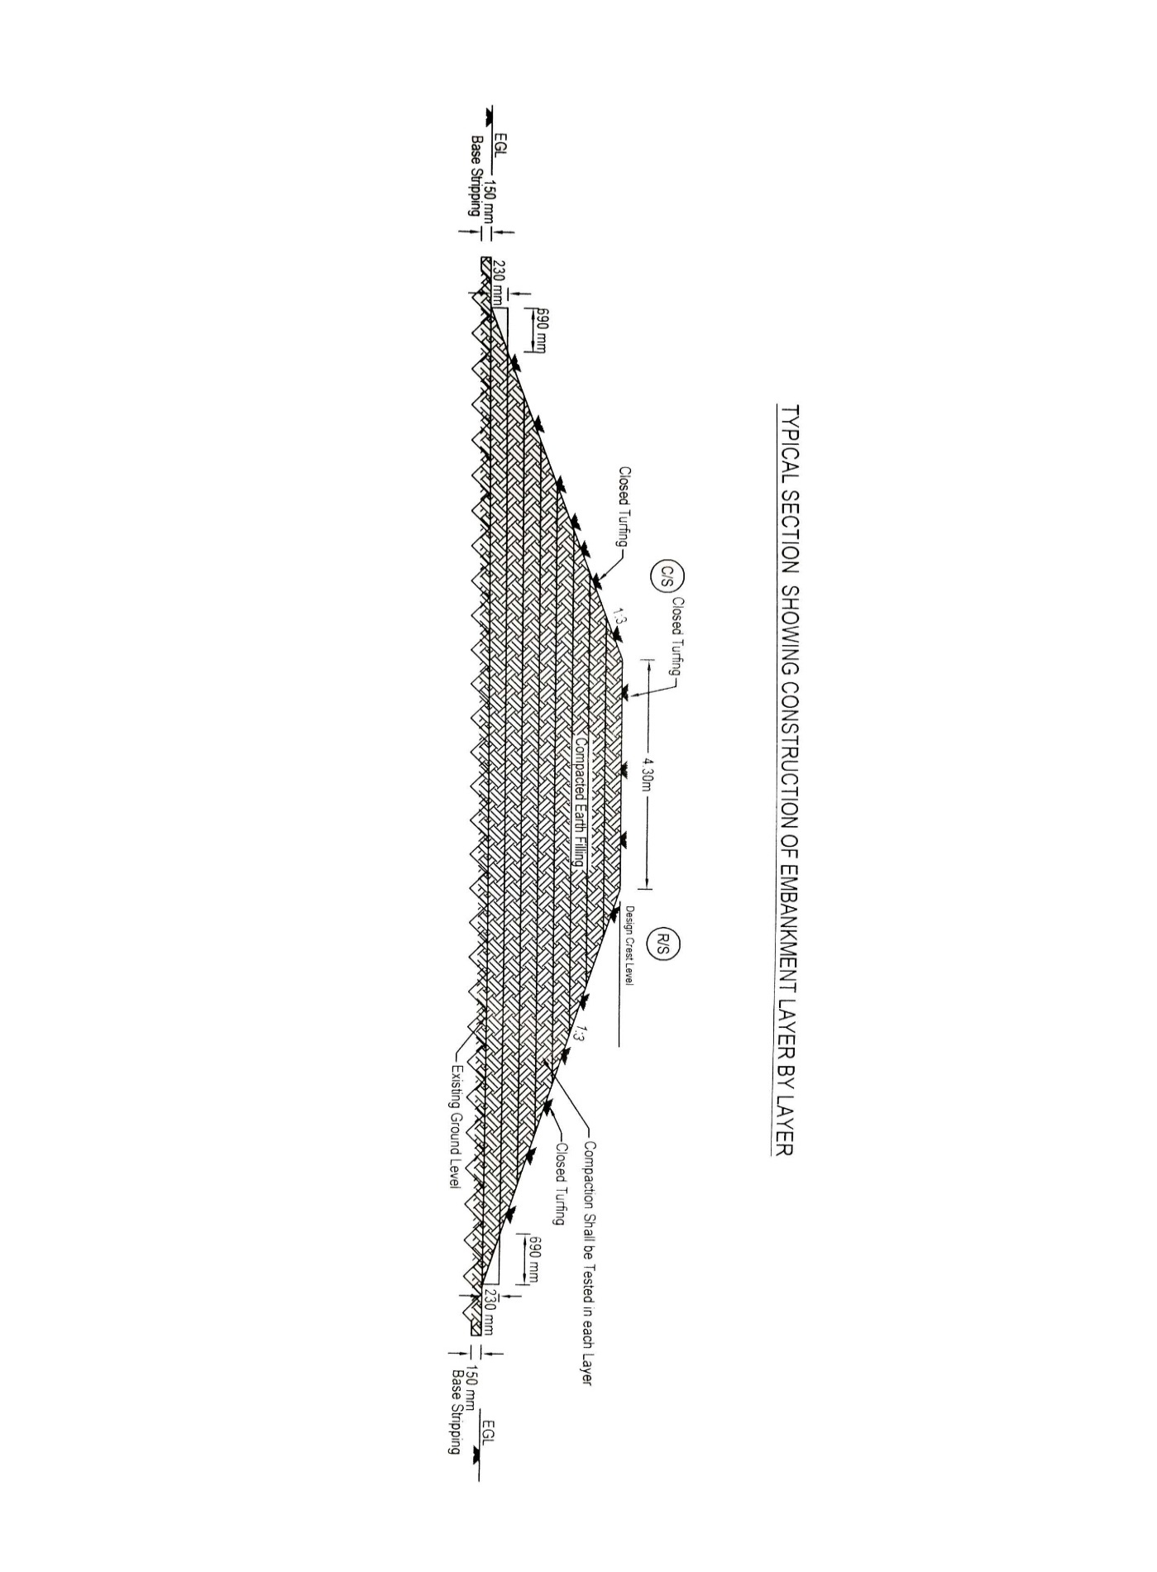

Annexure-2

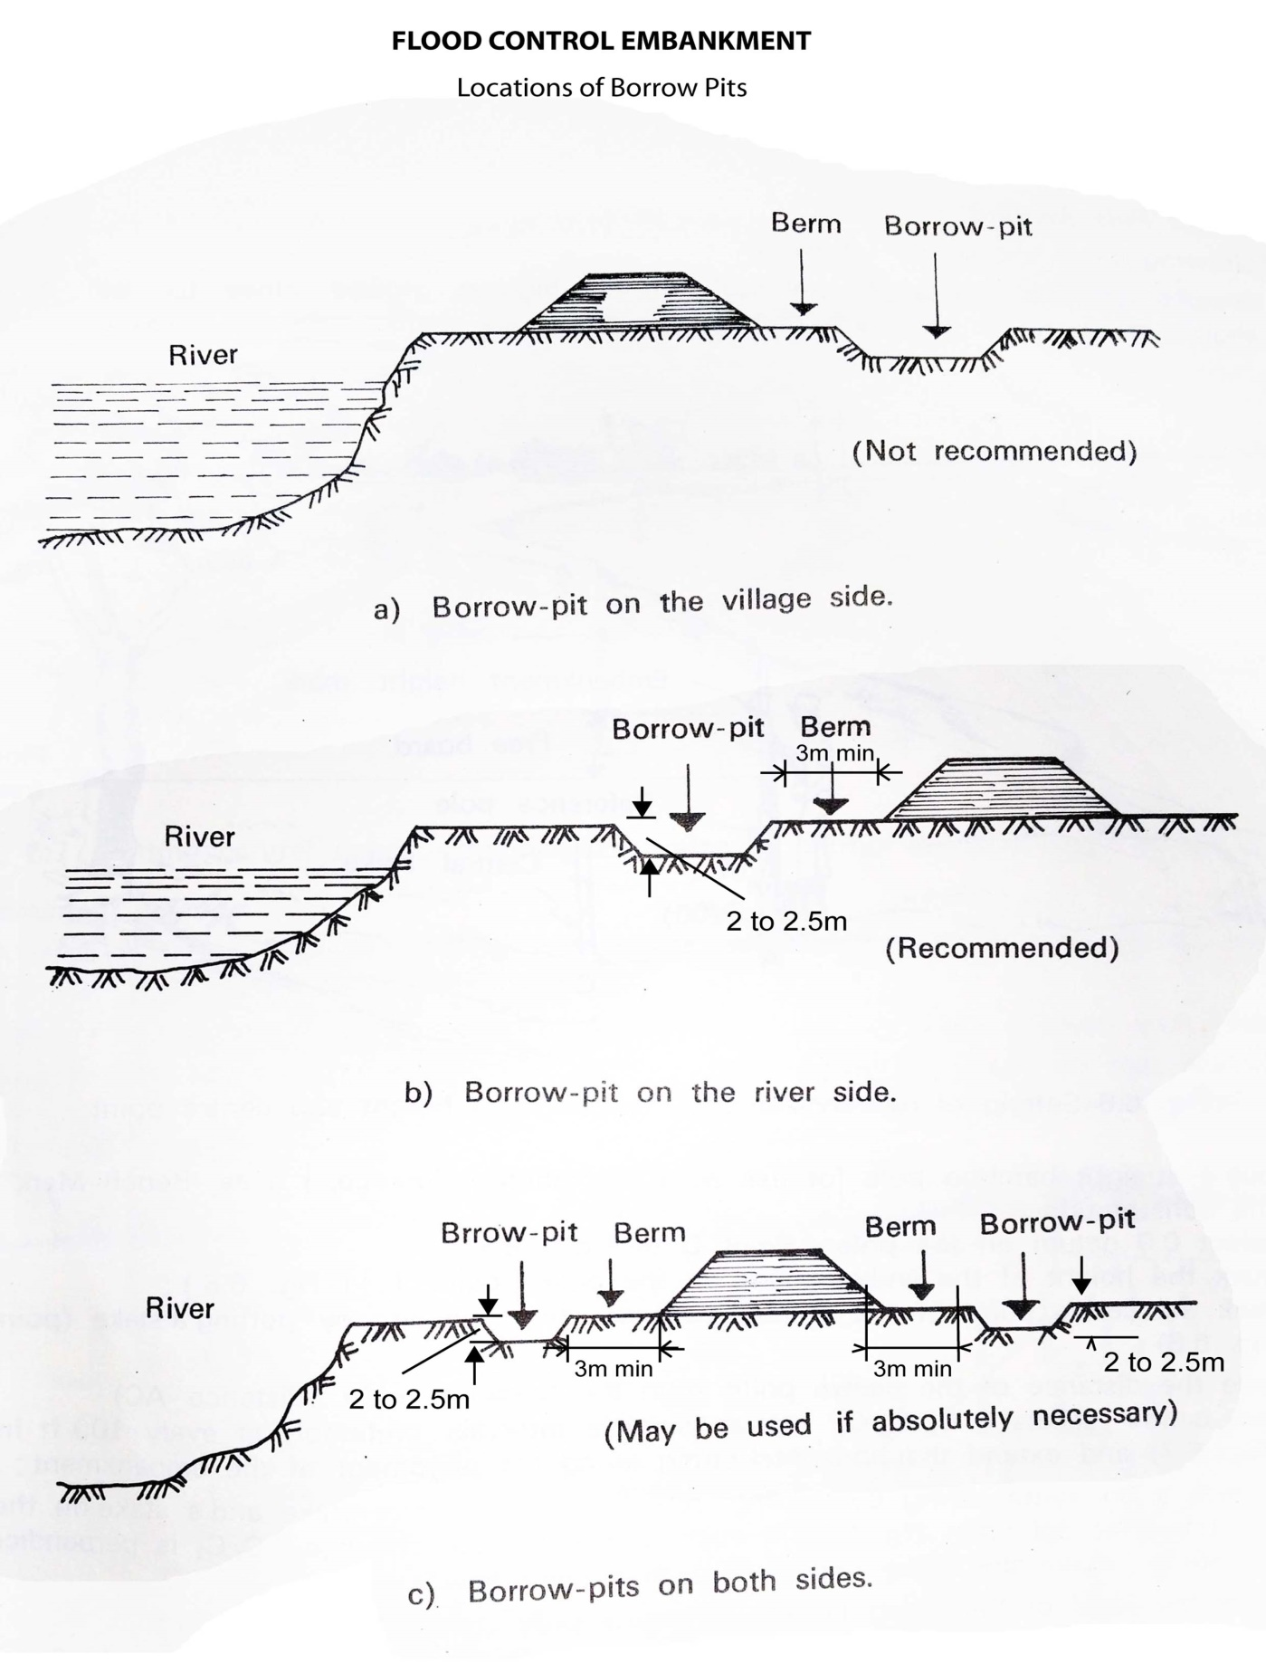

Berm

20m min

50m min

20m min